Chapter – 15

**Pure component:**

It is used to boost the performance of component (don’t use it unless required)

1. 🡪We can create a component by extending the PureComponent class.

import React, { PureComponent } from "react";

class PureComp extends PureComponent {

  render() {

    console.log("Pure Component");

    return <div>Pure Component</div>;

  }

}

export default PureComp;

1. A PureComponent implements the shouldComponentUpdate lifecycle method by performing a shallow comparison on the props and states of the component.

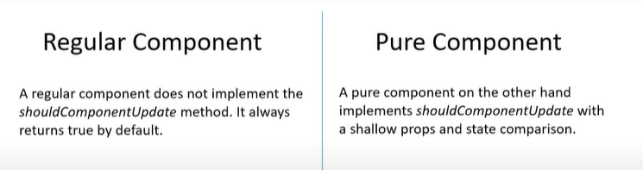

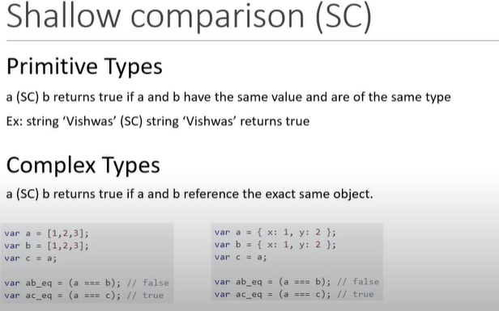

import React, { Component } from "react";

class RegComp extends Component {

  render() {

    console.log("Regular Component");

    return <div>Regular Component {this.props.name}</div>;

  }

}

export default RegComp;

import React, { PureComponent } from "react";

class PureComp extends PureComponent {

  render() {

    console.log("Pure Component");

    return <div>Pure Component {this.props.name}</div>;

  }

}

export default PureComp;

import React, { Component } from "react";

import RegComp from "./Ch15RegularComponent";

import PureComp from "./Ch15PureComponent";

class ParentComp extends Component {

  constructor(props) {

    super(props);

    this.state = {

      name: "abhi"

    };

  }

  componentDidMount() {

    setInterval(() => {

      this.setState({

        name: "abhi"

      });

    }, 2000);

  }

  render() {

    console.log("******************Parent Component**************");

    return (

      <div>

        Parent Component

        <RegComp name={this.state.name} />

        <PureComp name={this.state.name} />

      </div>

    );

  }

}

export default ParentComp;

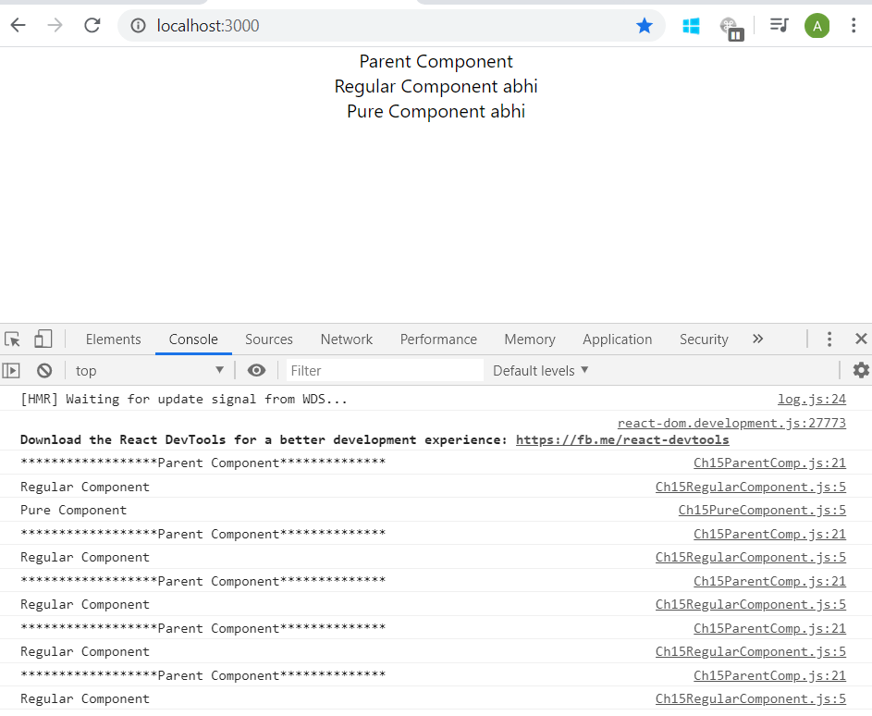

Note: - if we make 2nd component (regular component) also the pure component then this infinite logging in console will stop.

1. When we use any parent component as PureComponent then we need to make sure children component is also PureComponent to avoid unexpected behavior.
2. When we use PureComponent then we should never mutate the state, always return a new object that reflect the new state.